Polymorphism

1. What is polymorphism?
   * **Polymorphism** is an object-oriented programming concept that refers to the ability of a variable, function, or object to take on multiple forms.
   * **Polymorphism** is the ability of an object to take on many forms.
2. What is overwrite and override?
   * "**Override**" is the cancellation of some previous action or decision.
   * "**Overwrite**" specifically refers to something being written over something previously written.
   * 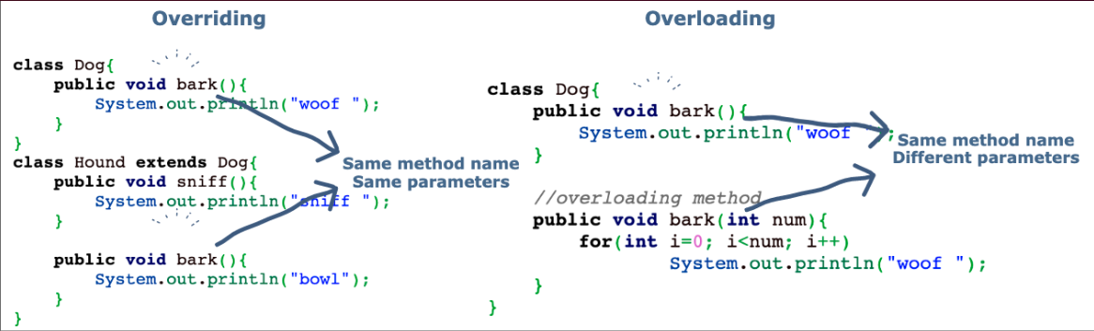“**Overloading**” occurs when two or more methods in one class have the same method name but different parameters.
3. An **enum** is a special type that represents a group of constants (unchangeable values).( A **enum** is a set of predefined **named value** )

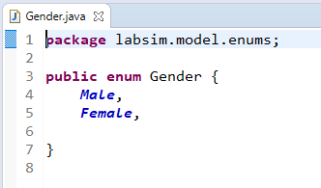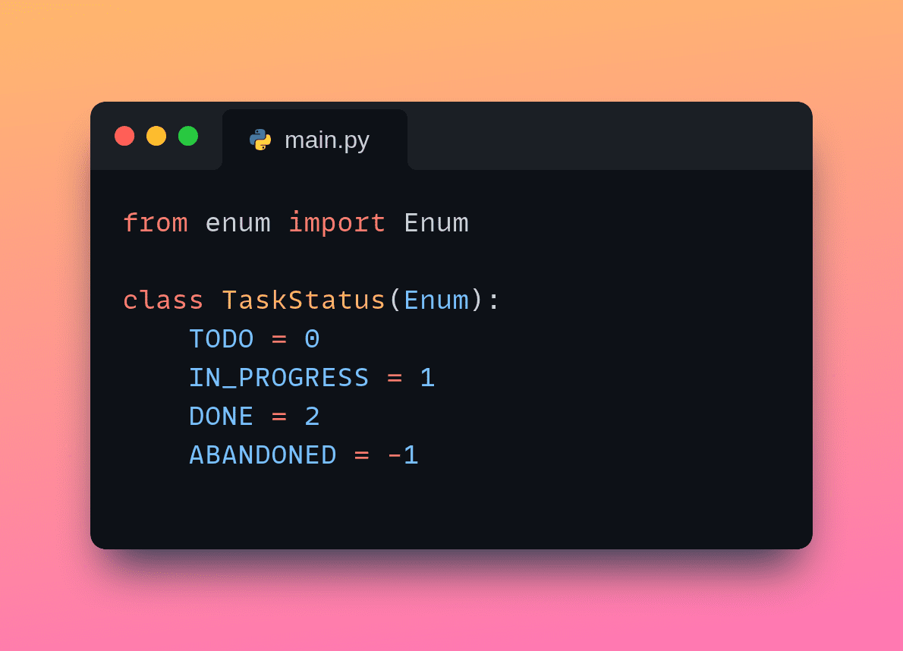

1. Polymorphism

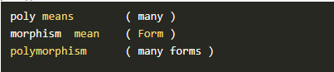

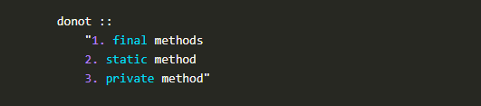

1. Types of polymorphism
   * Compile time polymorphism
     + 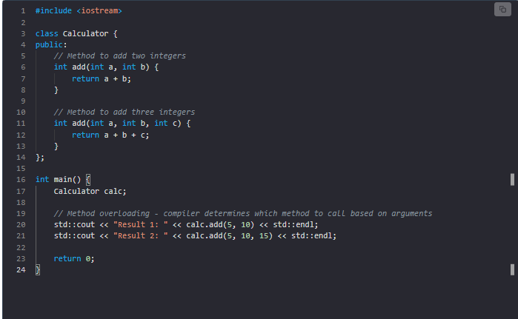Example: Method overloading
   * Runtime polymorphism
     + 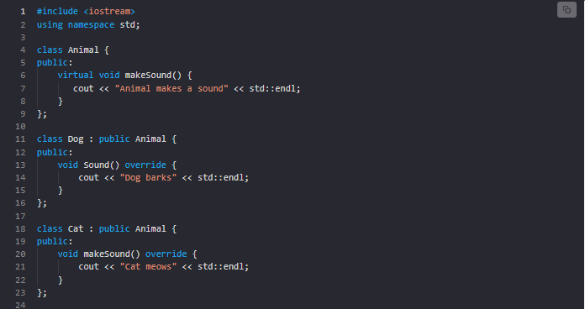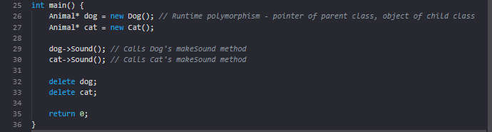Example: Method overriding
2. Advantages of polymorphism:
   * It helps programmers reuse code and classes once written, tested, and implemented.
   * A single variable name can be used to store variables of multiple data types (float, double, long, int, etc).
   * It helps compose powerful, complex abstractions from simpler ones.